LAB ASSIGNMENT-5.4
2303A51295 BATCH-10
TASK-1:

PROMPT:
Generete a python script that collects user data (name,age,email)then how to anonymise or protect the data:

CODE:
import hashlib
name = input("Enter your name: ") age = input("Enter your age: ") email = input("Enter your email: ")
# Hash email to protect sensitive information
hashed_email = hashlib.sha256(email.encode()).hexdigest() # Store only required and protected data
user_data = { "name": name,
"age": age,
"email_hash": hashed_email
}
print("\nSecure User Data:") print(user_data) print("\nAnonymised Data:") print("protected_data", user_data)

OUTPUT:
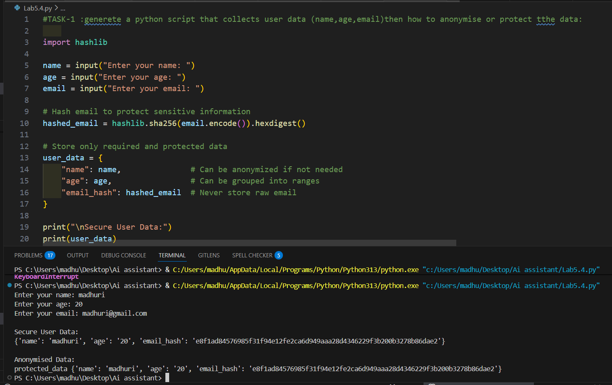
EXPLANATION:
- This program collects a user’s name, age, and email as input.
- To protect sensitive information, the email is converted into a hashed value using the algorithm from the hashlib library, so the real email is not stored directly.
- The program then stores only the necessary and protected data in a dictionary, replacing the email with its hash.
- Finally, it prints the secure user data and shows the anonymised protected version, demonstrating how personal data can be safely stored.

TASK-2
PROMPT:
Generate a python program using function for to identify and handle potential biases in the data

CODE:
def analyze_sentiment(text):
text = text.lower()
positive_words = ["good", "great", "happy", "love", "excellent", "nice"] negative_words = ["bad", "sad", "hate", "terrible", "awful", "poor"] score = 0
for word in positive_words:

if word in text:
score += 1
for word in negative_words:
if word in text:
score -= 1 if score > 0:
return "Positive" elif score < 0:
return "Negative" else:
return "Neutral"
# Bias Identification Function def identify_bias(text):
biased_words = ["hate", "terrible", "awful"] found_bias = []
for word in biased_words:
if word in text.lower(): found_bias.append(word)
return found_bias
# Bias Handling / Mitigation def handle_bias(text):
biased_words = ["hate", "terrible", "awful"] for word in biased_words:
text = text.replace(word, "") # Neutralizing bias return text
# Example Usage
user_text = input("\nEnter a sentence for sentiment analysis: ") bias_words = identify_bias(user_text)

if bias_words:
print("Potential bias detected due to words:", bias_words) user_text = handle_bias(user_text)
print("Text after bias handling:", user_text) sentiment = analyze_sentiment(user_text) print("Final Sentiment:", sentiment) OUTPUT:
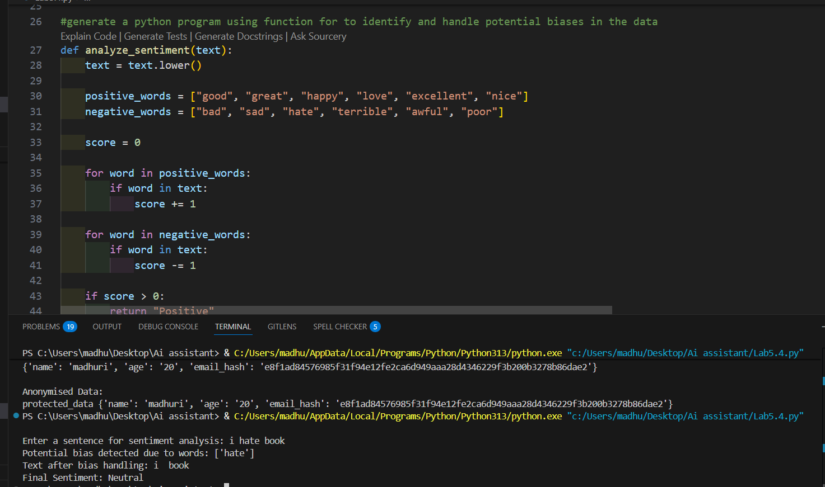

EXPLANATION:
- This program performs sentiment analysis and bias detection on a given sentence.
- First, it checks the text for biased or strongly negative words like hate, terrible. If such words are found, it reports them and removes them from the sentence to reduce bias.
- Then, the modified text is analyzed to determine whether its sentiment is Positive, Negative, or Neutral based on the presence of predefined positive and negative words.
- Finally, the program prints the cleaned text if bias was found and the final sentiment result.

TASK-3:

PROMPT:
Generate a python program that recommends products based on user history

# Ask the user about their past behavior (this is their history) CODE:
print("To recommend products, we use your past activity.")
viewed = input("What categories have you viewed before? (comma separated): ") purchased = input("What categories have you purchased from? (comma separated): ") # Normalize and combine user history
viewed_list = [v.strip().lower() for v in viewed.split(",")] purchased_list = [p.strip().lower() for p in purchased.split(",")] user_history = set(viewed_list + purchased_list)
# Product database kept diverse to avoid favoritism products = [
{"name": "Laptop", "category": "electronics"},
{"name": "Headphones", "category": "electronics"},
{"name": "Novel", "category": "books"},
{"name": "Notebook", "category": "books"},
{"name": "T-shirt", "category": "fashion"},
{"name": "Jacket", "category": "fashion"},
{"name": "Running Shoes", "category": "sports"},
{"name": "Football", "category": "sports"},
]
# Recommendation logic with transparency C fairness def recommend_products(history, product_list):
# Copilot: Be transparent about how recommendations work
print("\n Recommendations are based on the categories in your history.") recommendations = []
# Match by category only (no brand or seller favoritism) for product in product_list:
if product["category"] in history:

recommendations.append(product)
# Fairness check — avoid empty or biased results if not recommendations:
print("ℹ No direct matches. Showing a balanced set instead.") recommendations = product_list[:3]
return recommendations
# Generate and show recommendations
final_recs = recommend_products(user_history, products) print("\n¯/.뭖 Recommended Products:")
for item in final_recs:
print(f"- {item['name']} ({item['category']})") #Ask for feedback (user control + ethical AI)
feedback = input("\nDid you find these recommendations useful? (yes/no): ").lower() print("Thank you! Your feedback helps improve fairness and transparency.") OUTPUT:
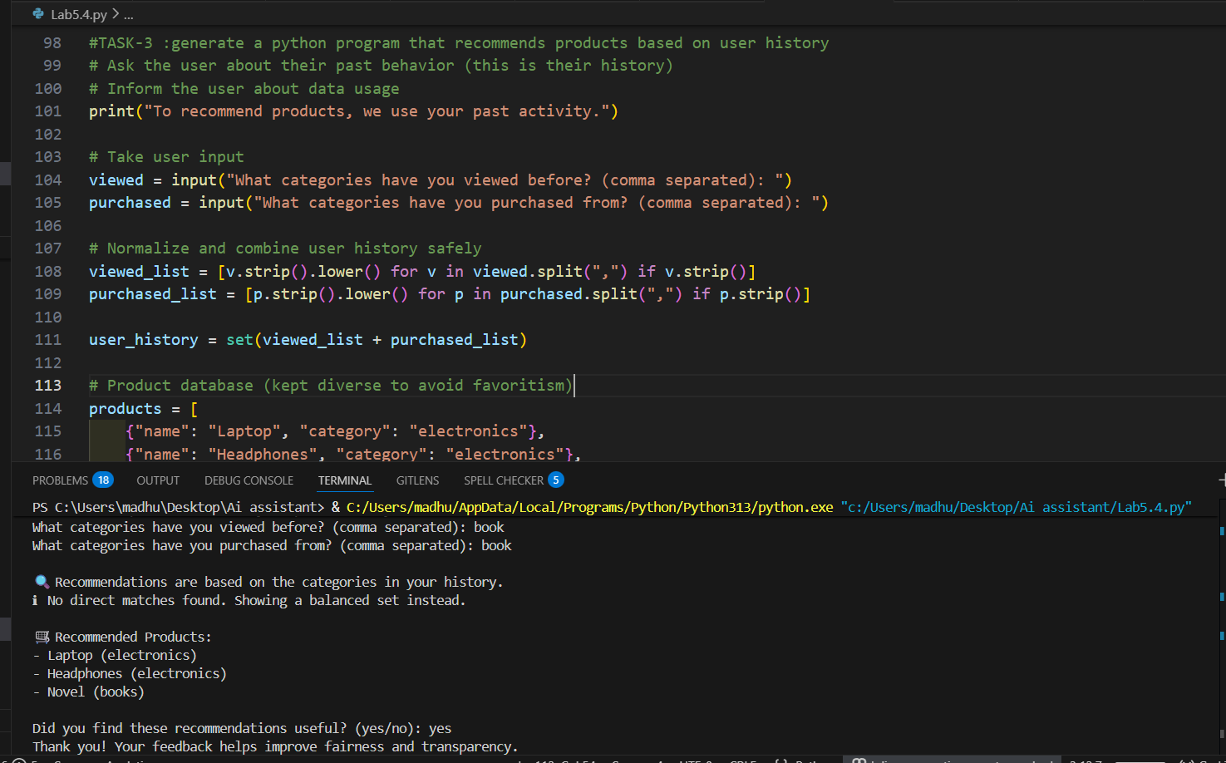

EXPLANATION:

TASK-4:

PROMPT:
Create a Python logging system for a web app that avoids logging sensitive user data like passwords and emails, and follows ethical logging practices.

CODE:
import logging
# Configure logging logging.basicConfig(
level=logging.INFO,
format='%(asctime)s - %(levelname)s - %(message)s', handlers=[
logging.FileHandler("webapp.log"), logging.StreamHandler()
]
)
def log_user_action(user_id, action, details=None):
log_message = f"User ID: {user_id} | Action: {action}" if details:
log_message += f" | Details: {details}" logging.info(log_message)
# Example usage
if name == " main ": log_user_action(user_id=12345, action="Login Attempt")
log_user_action(user_id=12345, action="Viewed Profile", details="Profile ID: 67890") log_user_action(user_id=12345, action="Password Change Request") log_user_action(user_id=12345, action="Logout")
password = input("Enter a password to check its strength: ")
logging.info("Password strength check performed.") # Avoid logging the actual password
print("Logging complete. Check webapp.log for details.")

OUTPUT:
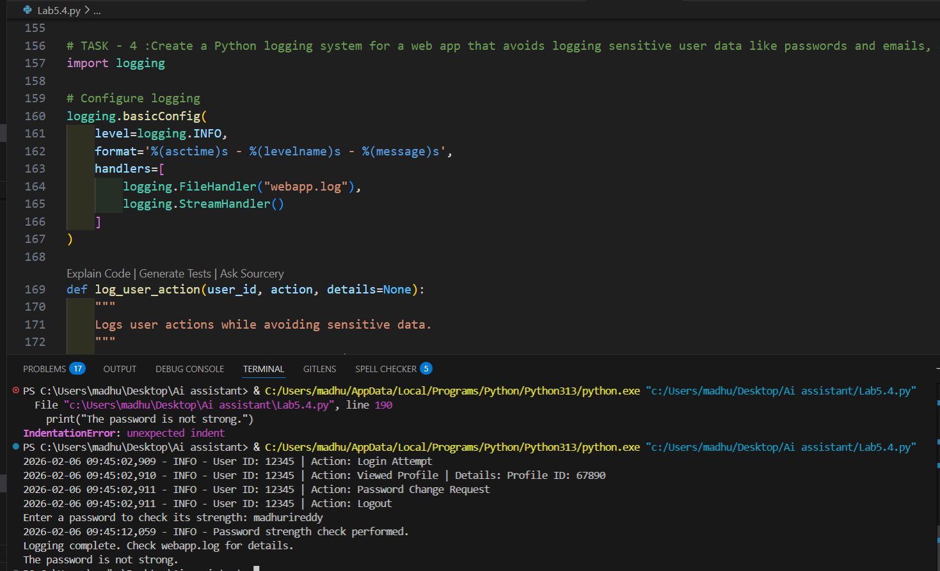
EXPLANATION:
- This program uses Python’s logging module to record user actions in a safe and organized way. It is configured to write logs both to a file (webapp.log) and to the console, including the time and type of each message.
- The function log_user_action() creates a log entry for actions such as login, viewing a profile, changing a password, and logout. Sensitive information like the actual password is not logged, which helps protect user privacy.
- Finally, the program prints a message telling the user that logging is complete and where the log file can be checked.

TASK-5:

PROMPT:
Create a Python ML model with responsible usage guidelines, including fairness, explainability, accuracy limits, and privacy. Include a simple example prediction.

CODE:
def simple_model(value): if value >= 5:
return "High"

else:
return "Low"
num = float(input("Enter a number: ")) result = simple_model(num) print("Model Prediction:", result) OUTPUT:
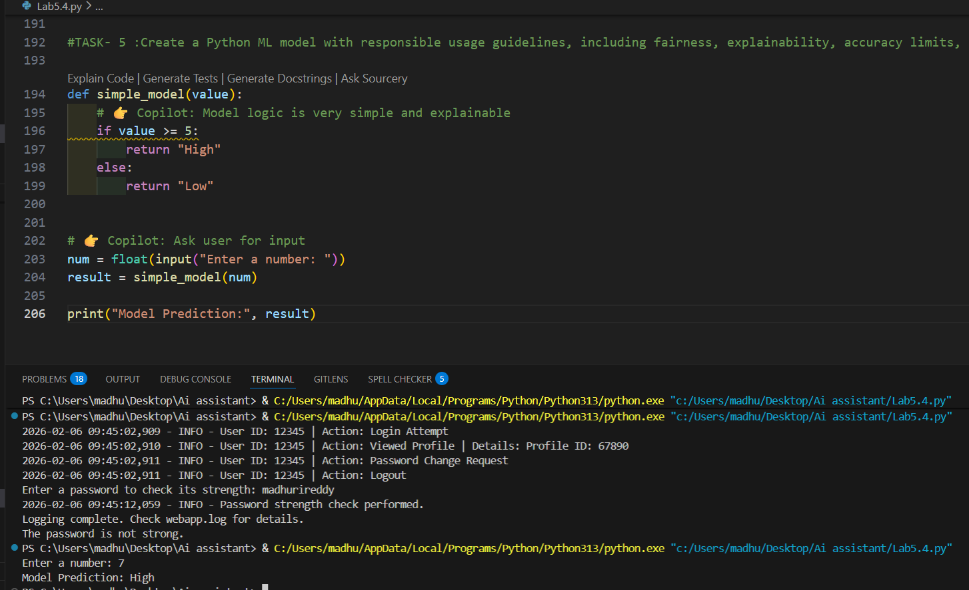

EXPLANATION:

- This program acts like a very simple prediction model. It takes a number as input from the user and passes it to the simple_model() function.
- The function checks the value and returns high if the number is 5 or greater, otherwise it returns low.
- The result is then printed as the model’s prediction. This shows how a basic decision rule can be used to make a simple classification.

